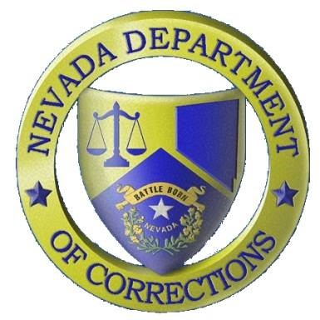
Nevada Department of Corrections
_________________________________
Public Information Office: 775-887-3309
PIO Scott Kelley Cell: 775-350-0037

Press Release
For Immediate Release:
July 15, 2019

The Nevada Department of Corrections (NDOC) reports that on Monday, July 15, 2019 at approximately 8:20 AM, Inmate Lynn Haynie #35009 was found unresponsive in his cell in the infirmary. Staff performed cardiopulmonary resuscitation but Haynie was pronounced deceased. Haynie, a 63-year old male, was a Clark County commit serving 48-to-120 months for driving under the influence. He arrived at the NDOC on November 18, 2015. Preliminary cause of death is natural causes due to long standing medical conditions. An autopsy will be scheduled per NRS 209.3815. Haynie had no next-of-kin listed.
Lynn Haynie

